Suggested Books on Personal Finance
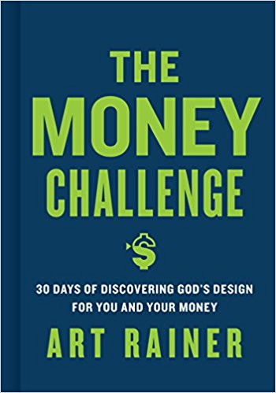
The Money Challenge – Art Rainer
“This isn’t where you thought you would be. You were meant for more. Your money was meant for more. You and your money are meant for an exciting, adventurous, and satisfying purpose. God designed you, not to be a hoarder, but a conduit through which His generosity flows. In The Money Challenge, Art Rainer takes you on a journey to financial health. But it is not simply for the sake of financial health. The Money Challenge was written to help experience God’s design for you and your finances. Welcome to the adventure. Welcome to The Money Challenge.”
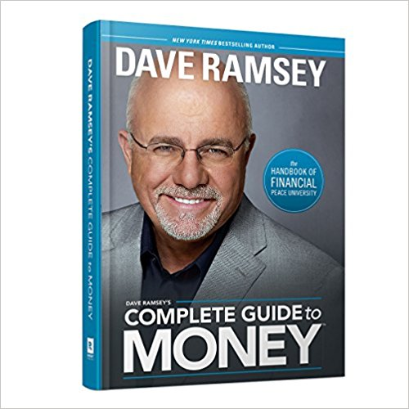
Complete Guide to Money – Dave Ramsey
“If you’re looking for practical information to answer all your “How?” “What?” and “Why?” questions about money, this book is for you. Dave Ramsey’s Complete Guide to Money covers the A to Z of Dave’s money teaching, including how to budget, save, dump debt, and invest. You’ll also learn all about insurance, mortgage options, marketing, bargain hunting and the most important element of all, giving.”

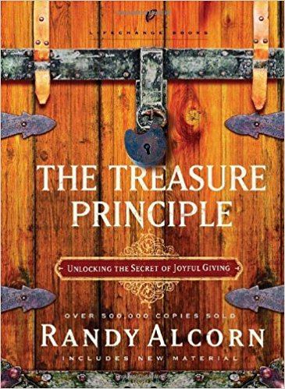
The Treasure Principle – Randy Alcorn
“In Randy Alcorn’s The Treasure Principle, you’ll unearth a radical teaching of Jesus – a secret wrapped up in giving. Once you discover this secret, life will never look the same. And you won’t want it to!”

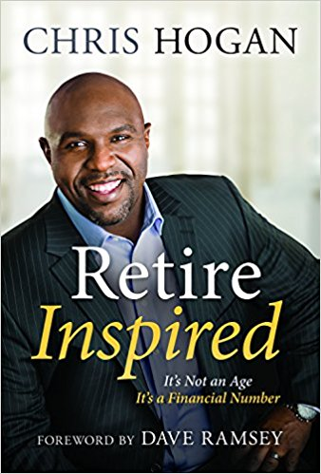
Retire Inspired – Chris Hogan
“When you hear the word retirement, you probably don't imagine yourself scrambling to pay your bills in your golden years. But for too many Americans, that's the fate that awaits unless they take steps now to plan for the future. Whether you're twenty five and starting your first job or fifty five and watching the career clock start to wind down, today is the day to get serious about your retirement. In Retire Inspired, Chris Hogan teaches that retirement isn't an age; it's a financial number an amount you need to live the life in retirement that you've always dreamed of. With clear investing concepts and strategies, Chris will educate and empower you to make your own investing decisions, set reasonable expectations for your spouse and family, and build a dream team of experts to get you there. You don't have to retire broke, stressed, and working long after you want to. You can retire inspired!”

